**A**

**Project Report**

on

**Restaurant management System**

Submitted to

# UKA TARSADIA UNIVERSITY

in

partial fulfilment for the degree of

**BACHELOR OF TECHNOLOGY**

**in**

# Computer Science and Engineering

Dhyan Moradiya (202103103510451)

Guided by

Mr. Ankita Desai

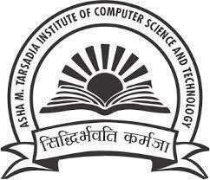

**Asha M. Tarsadia Institute of Computer Science and Technology**

**Uka Tarsadia University**

**Bardoli, Surat**

**November – 2022**